Homework 3 — SQL Fundamentals (Single-Table Queries)
SECTION A — ZAGI (5 Queries)
Question:
List the top 5 products by product price (columns: productid, productname, productprice) in descending price order.
SQL CODE:
-- Z1: Top 5 products by productprice
SELECT
productid,
productname,
productprice
FROM product
ORDER BY productprice DESC
LIMIT 5;
OUTPUT:
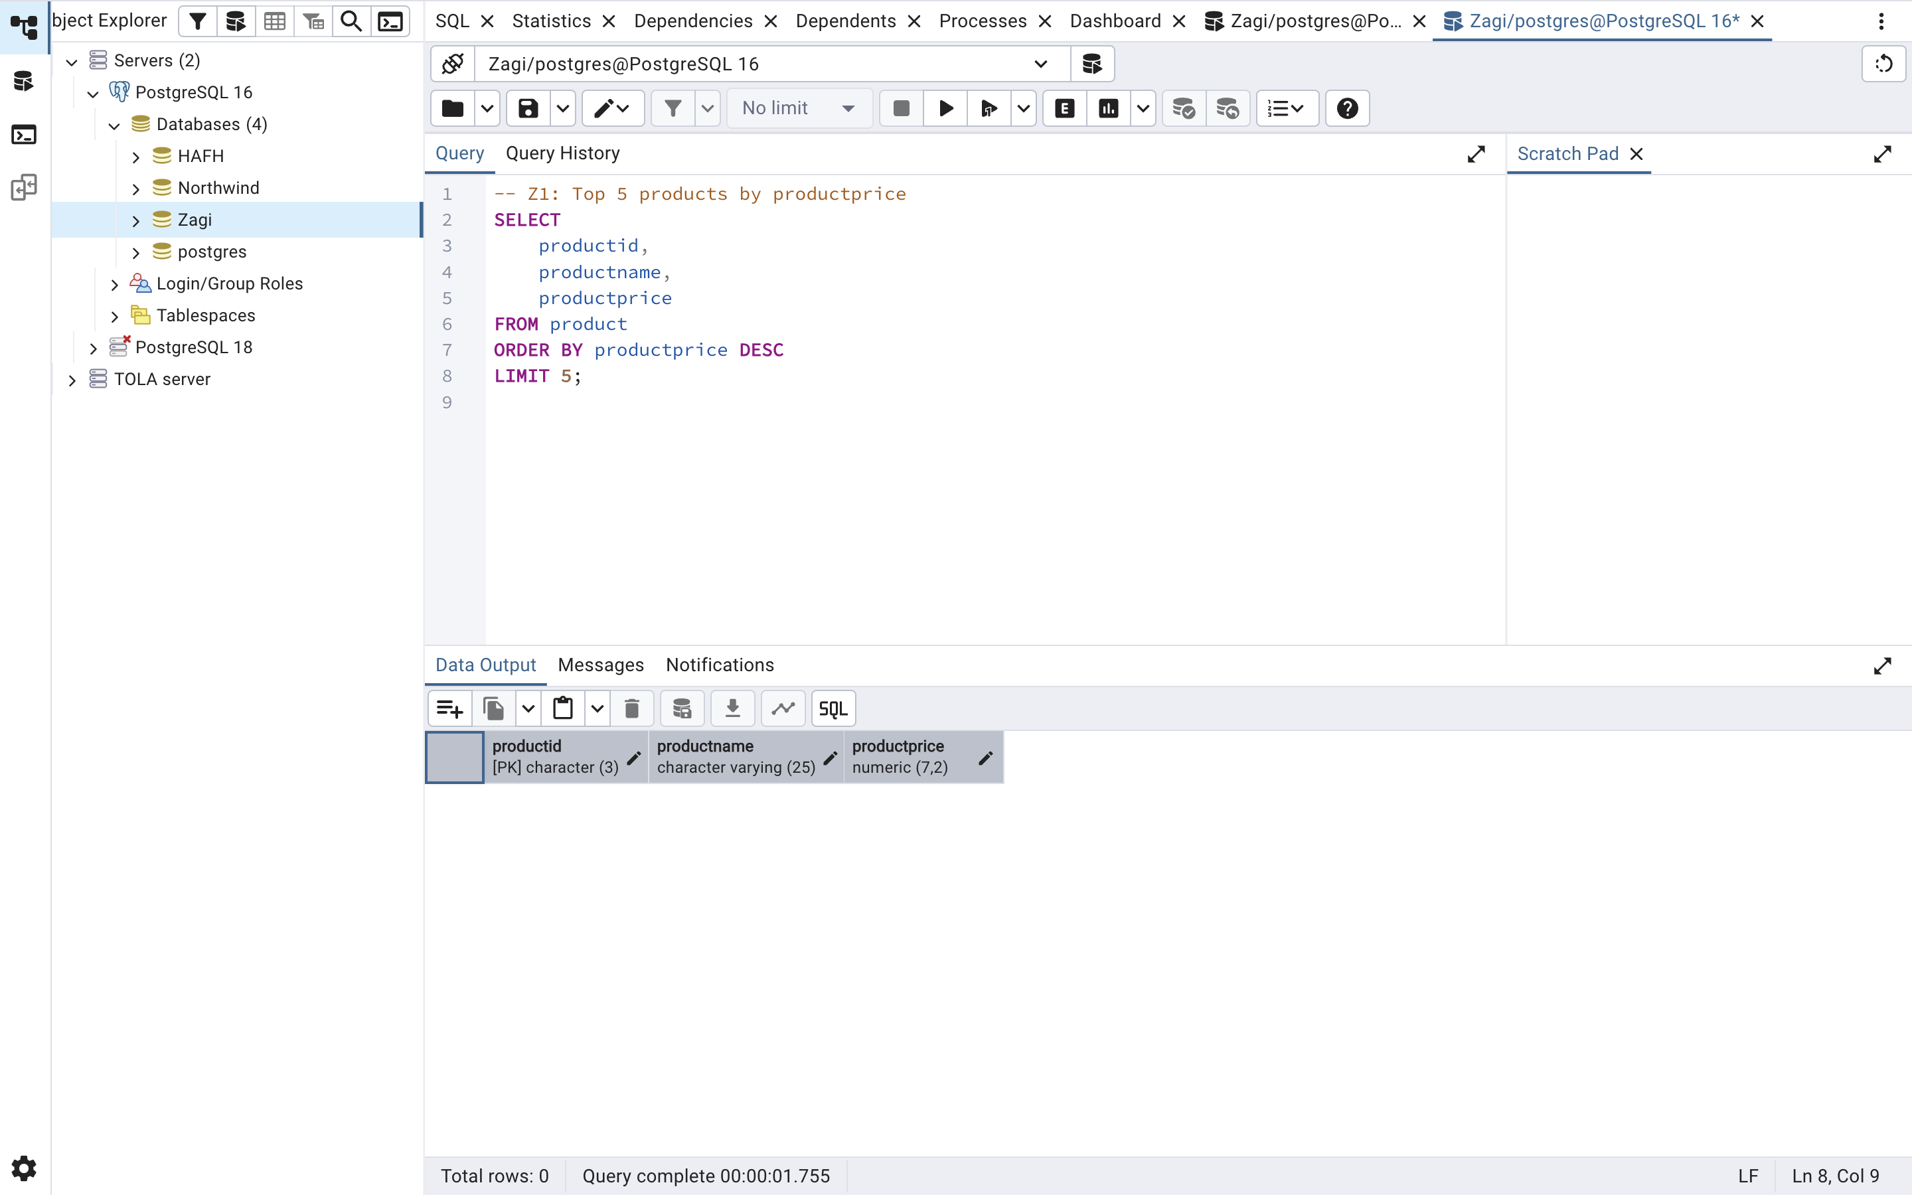

Z2 — Categories With More Than 2 Products
Question:
Using only the product table, return categoryid values with more than 2 products.
SQL Code:
-- Z2: Count products per category; return those with > 2
SELECT
categoryid,
COUNT(*) AS product_count
FROM product
GROUP BY categoryid
HAVING COUNT(*) > 2
ORDER BY product_count DESC;

OUTPUT:
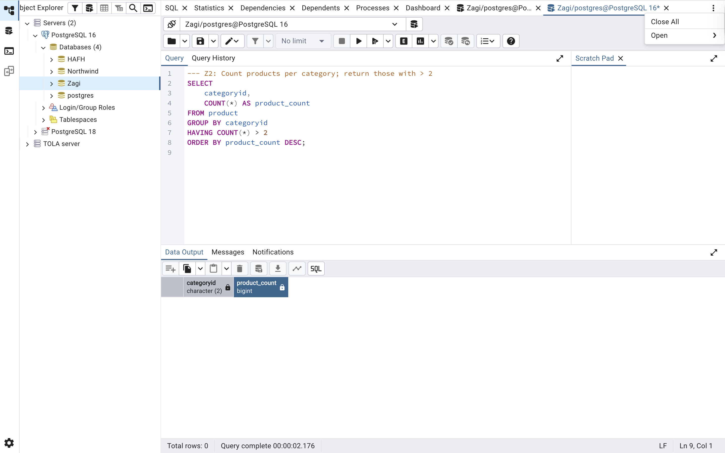

Z3 — Transactions Between 2013-01-02 and 2013-01-05
Question:
Count how many transactions occurred between '2013-01-02' and '2013-01-05' inclusive in
sales transaction (column date). Return a single row with txn_count.
SQL Code:
-- Z3: Count transactions in date range
SELECT
COUNT(*) AS txn_count
FROM salestransaction
WHERE tdate BETWEEN '2013-01-02' AND '2013-01-05';

OUTPUT:
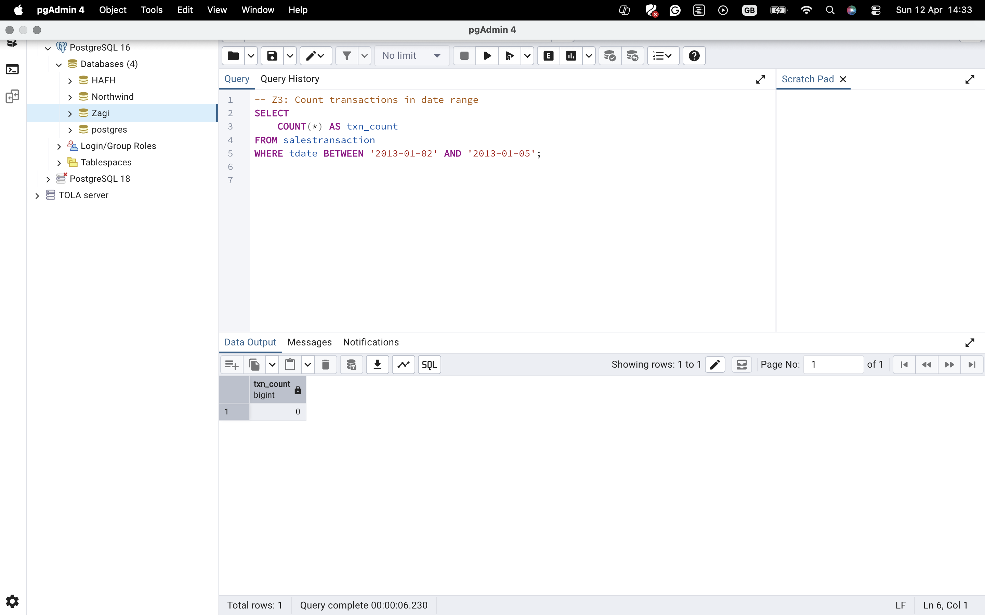

Z4 — Store Count Per Trimmed Region
Question.
For table store, return the number of stores per trimmed regionid as region, ordered by count desc—columns: region, store_count.

SQL Code:
-- Z4: Count stores per trimmed regionid
SELECT
TRIM(regionid) AS region,
COUNT(*) AS store_count
FROM store
GROUP BY TRIM(regionid)
ORDER BY store_count DESC;

OUTPUT: 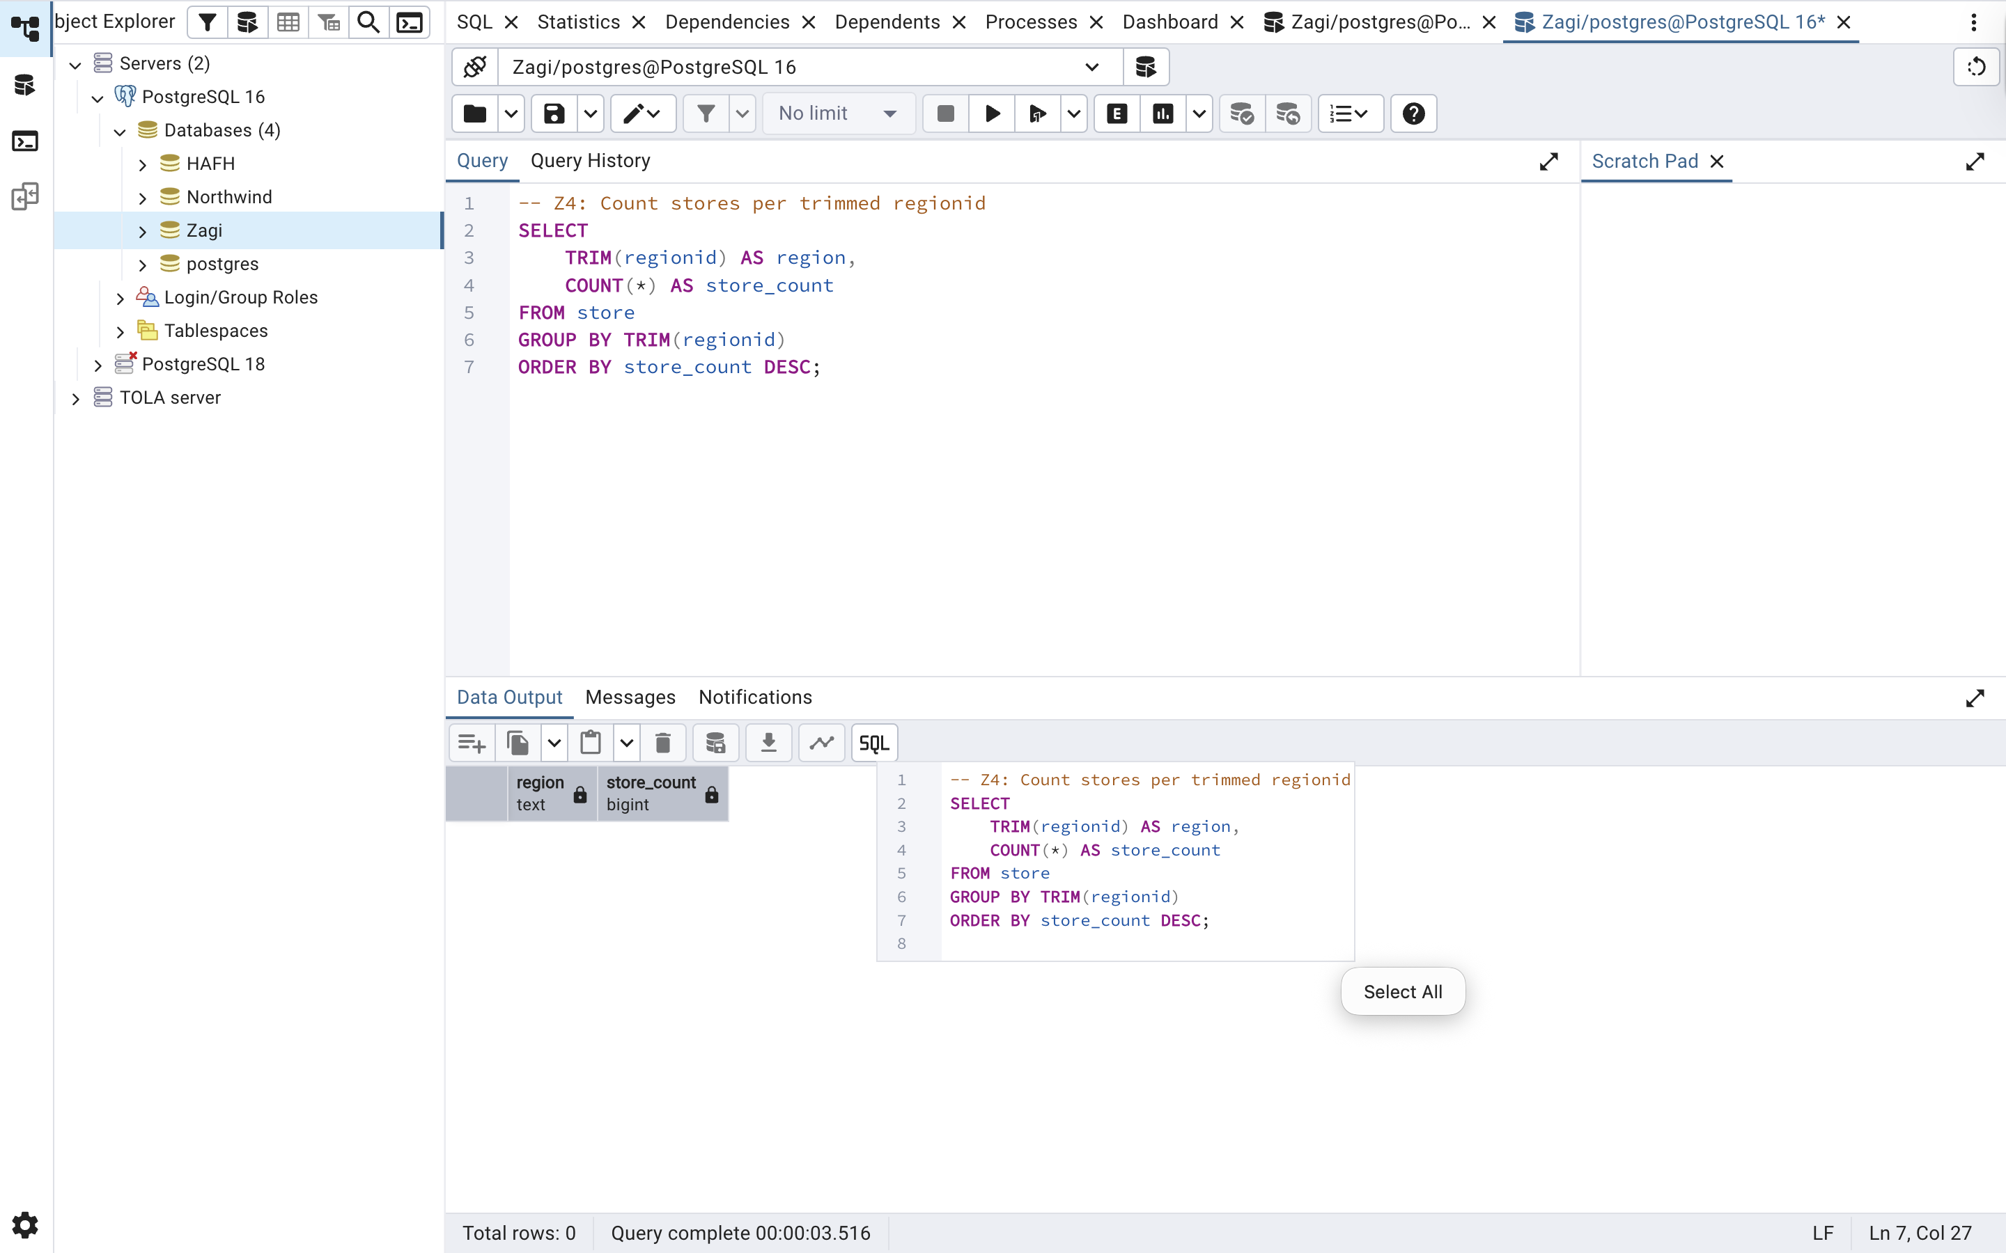

Z5 — Top 3 Products by Quantity Sold
Question:
From soldvia, return the top 3 productid by total quantity sold (noofitems). Columns:
productid, total_qty. Order by total_qty desc.
SQL Code:
-- Z5: Sum quantity sold per product; return top 3
SELECT
productid,
SUM(noofitems) AS total_qty
FROM soldvia
GROUP BY productid
ORDER BY total_qty DESC
LIMIT 3;

OUTPUT:
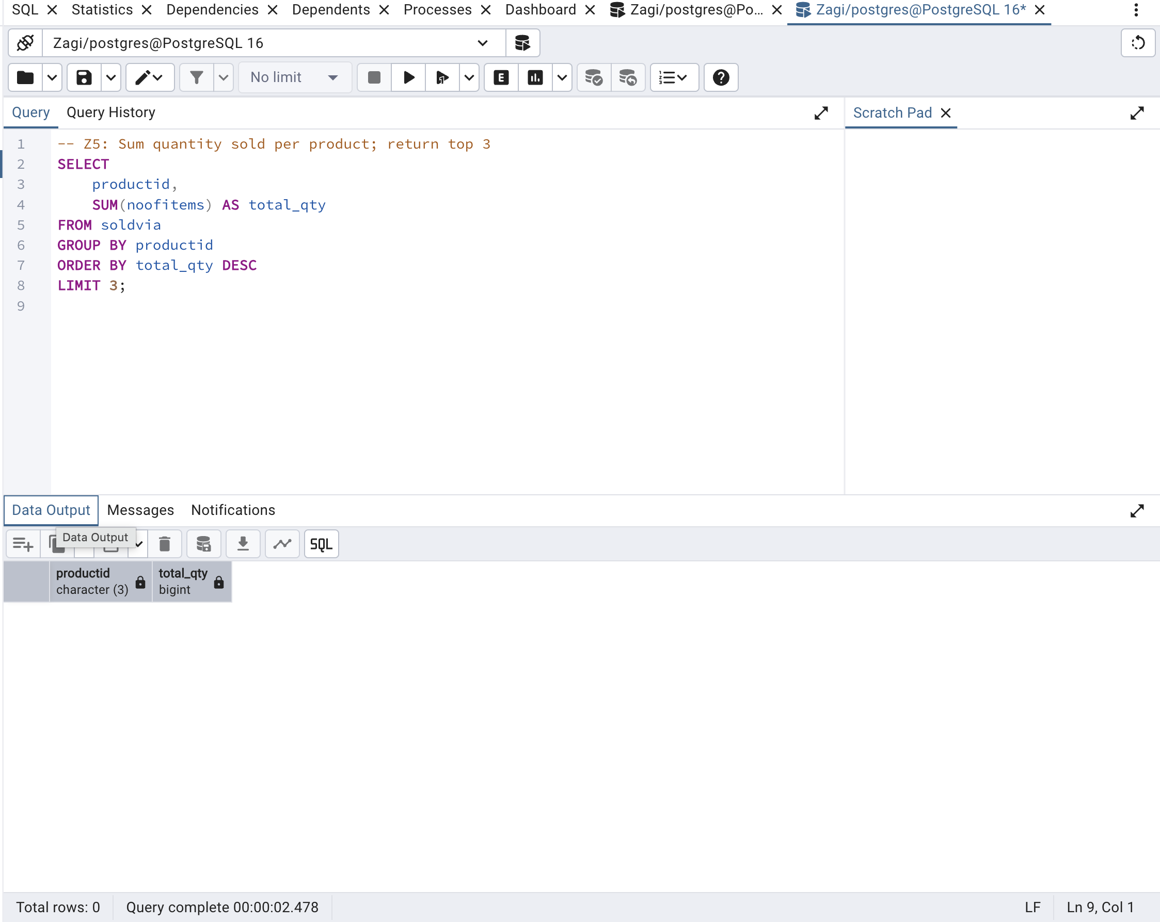

SECTION B — HAFH (5 QUERIES)
H1 — Salary stats + count of managers with bonus
QUESTION:
Return AVG (msalary), MIN(msalary), MAX(msalary) as avg_salary, min_salary, max_salary, and COUNT (*) FILTER (WHERE mbonus IS NOT NULL) as with_bonus (or an equivalent.
SQL CODE:
-- H1: Salary stats + count of non-null bonuses
SELECT
AVG(msalary) AS avg_salary,
MIN(msalary) AS min_salary,
MAX(msalary) AS max_salary,
COUNT(*) FILTER (WHERE mbonus IS NOT NULL) AS with_bonus
FROM manager;

OUTPUT:
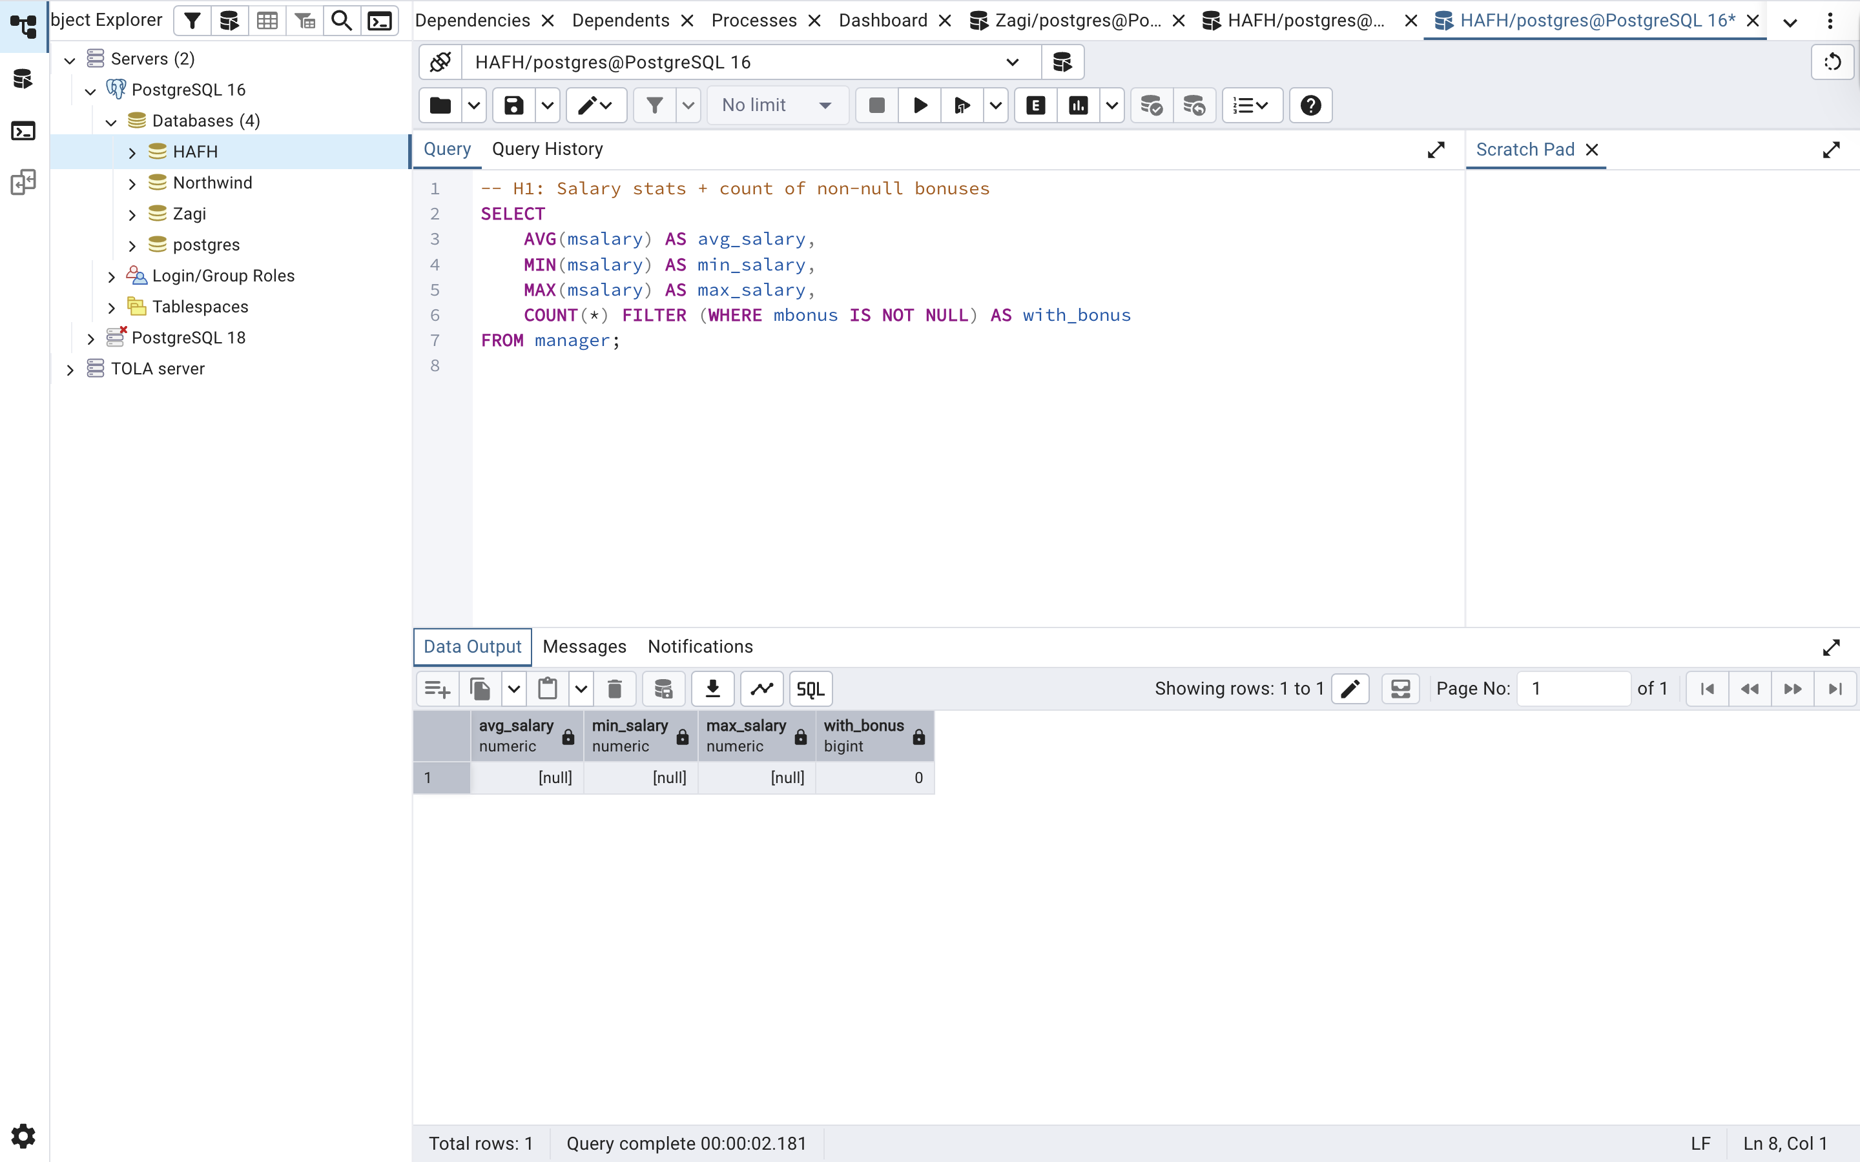

H2 — Buildings With ≥ 4 Floors
QUESTION:
List buildings with bnooffloors >= 4, ordered by bnooffloors desc then buildingid. Columns: buildingid, bnooffloors.

SQL CODE:
- H2: Buildings with 4 or more floors
SELECT
buildingid,
bnooffloors
FROM building
WHERE bnooffloors >= 4
ORDER BY bnooffloors DESC, buildingid;

OUTPUT:
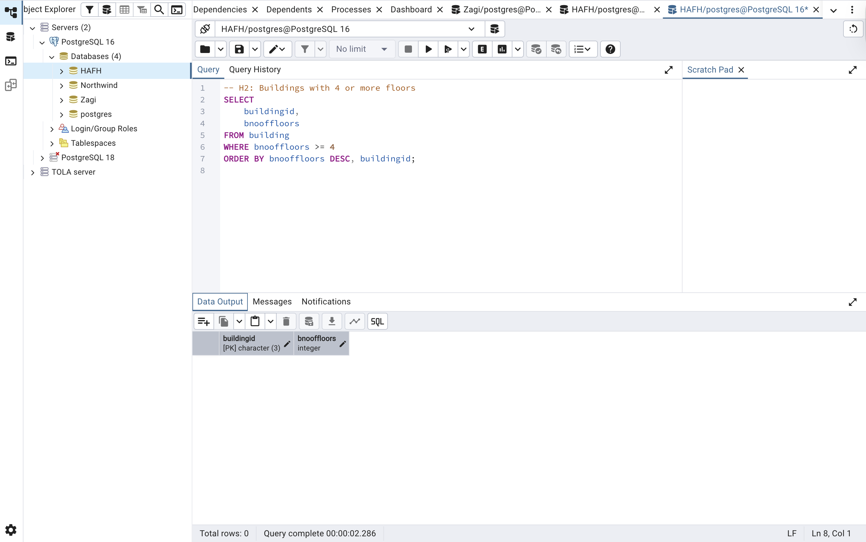

H3 — Industries With ≥ 3 Corporate Clients
QUESTIONS:
Count clients per cc industry. Return industries with COUNT(*) >= 3, ordered by count desc. Columns: ccindustry, client_count.
SQL CODE:
-- H3: Count clients per industry; return those with >= 3
SELECT
ccindustry,
COUNT(*) AS client_count
FROM corpclient
GROUP BY ccindustry
HAVING COUNT(*) >= 3
ORDER BY client_count DESC;

OUTPUT:
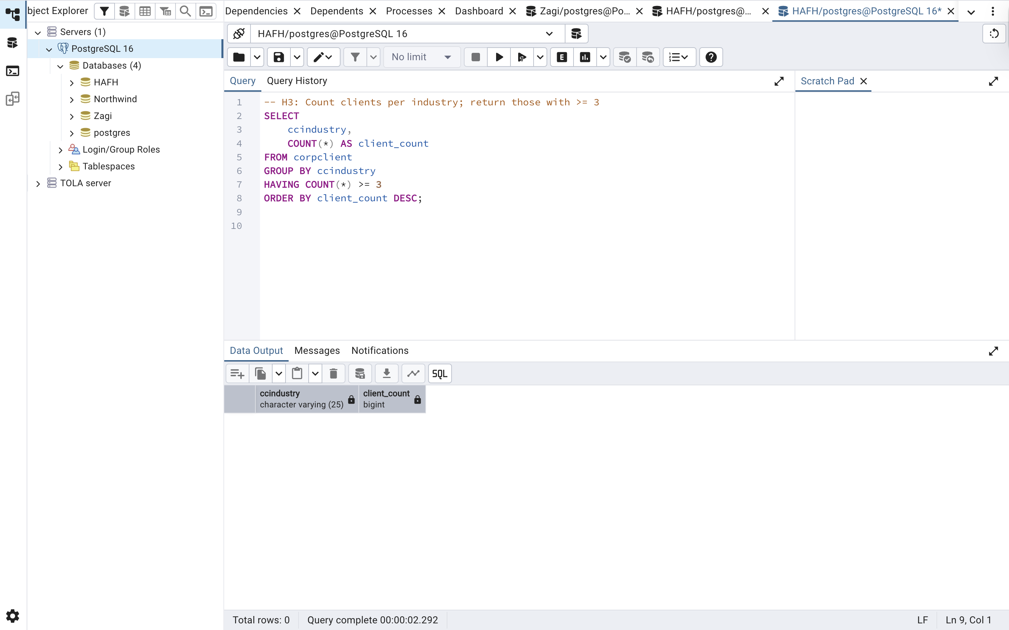

H4 — Inspectors with ≥ 2 inspections scheduled in 2014
QUESTION:
For rows where datenext is in 2014, return inspectors with at least 2 scheduled inspections. Columns: insid, inspection_count, ordered by inspection_count desc.

SQL CODE:
-- H4: Count 2014 inspections per inspector
SELECT
insid,
COUNT(*) AS inspection_count
FROM inspecting
WHERE EXTRACT(YEAR FROM datenext) = 2014
GROUP BY insid
HAVING COUNT(*) >= 2
ORDER BY inspection_count DESC;

OUTPUT: 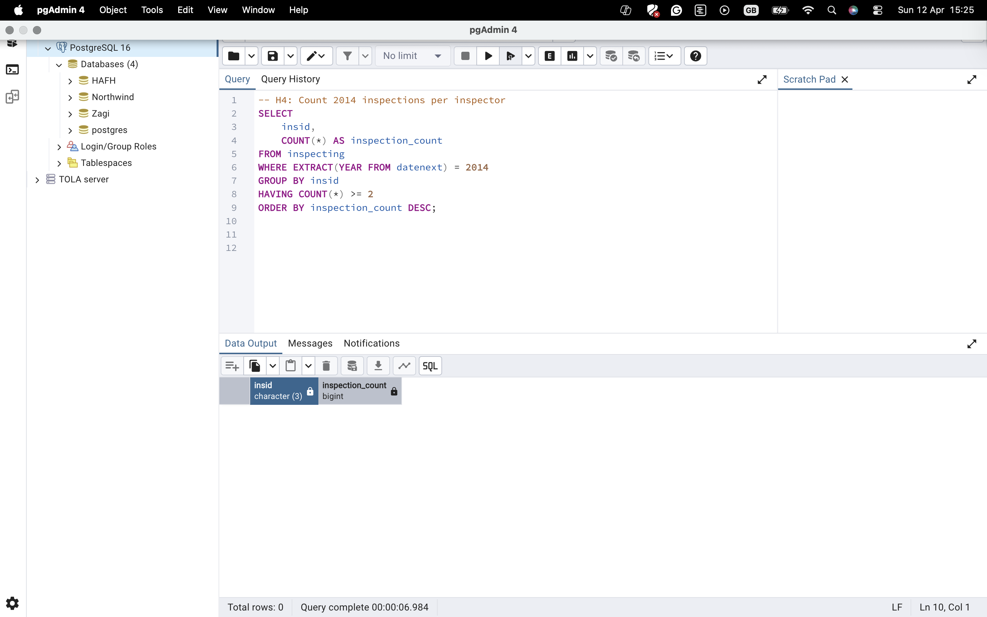

H5 — Managers with ≥ 2 phone numbers
QUESTION:
Count phone numbers per manager and return managers with COUNT(*) >= 2. Columns: managerid, phone_count, ordered desc.

SQL CODE:
-- H5: Count phone numbers per manager; return those with >= 2
SELECT
managerid,
COUNT(*) AS phone_count
FROM managerphone
GROUP BY managerid
HAVING COUNT(*) >= 2
ORDER BY phone_count DESC;

OUTPUT:
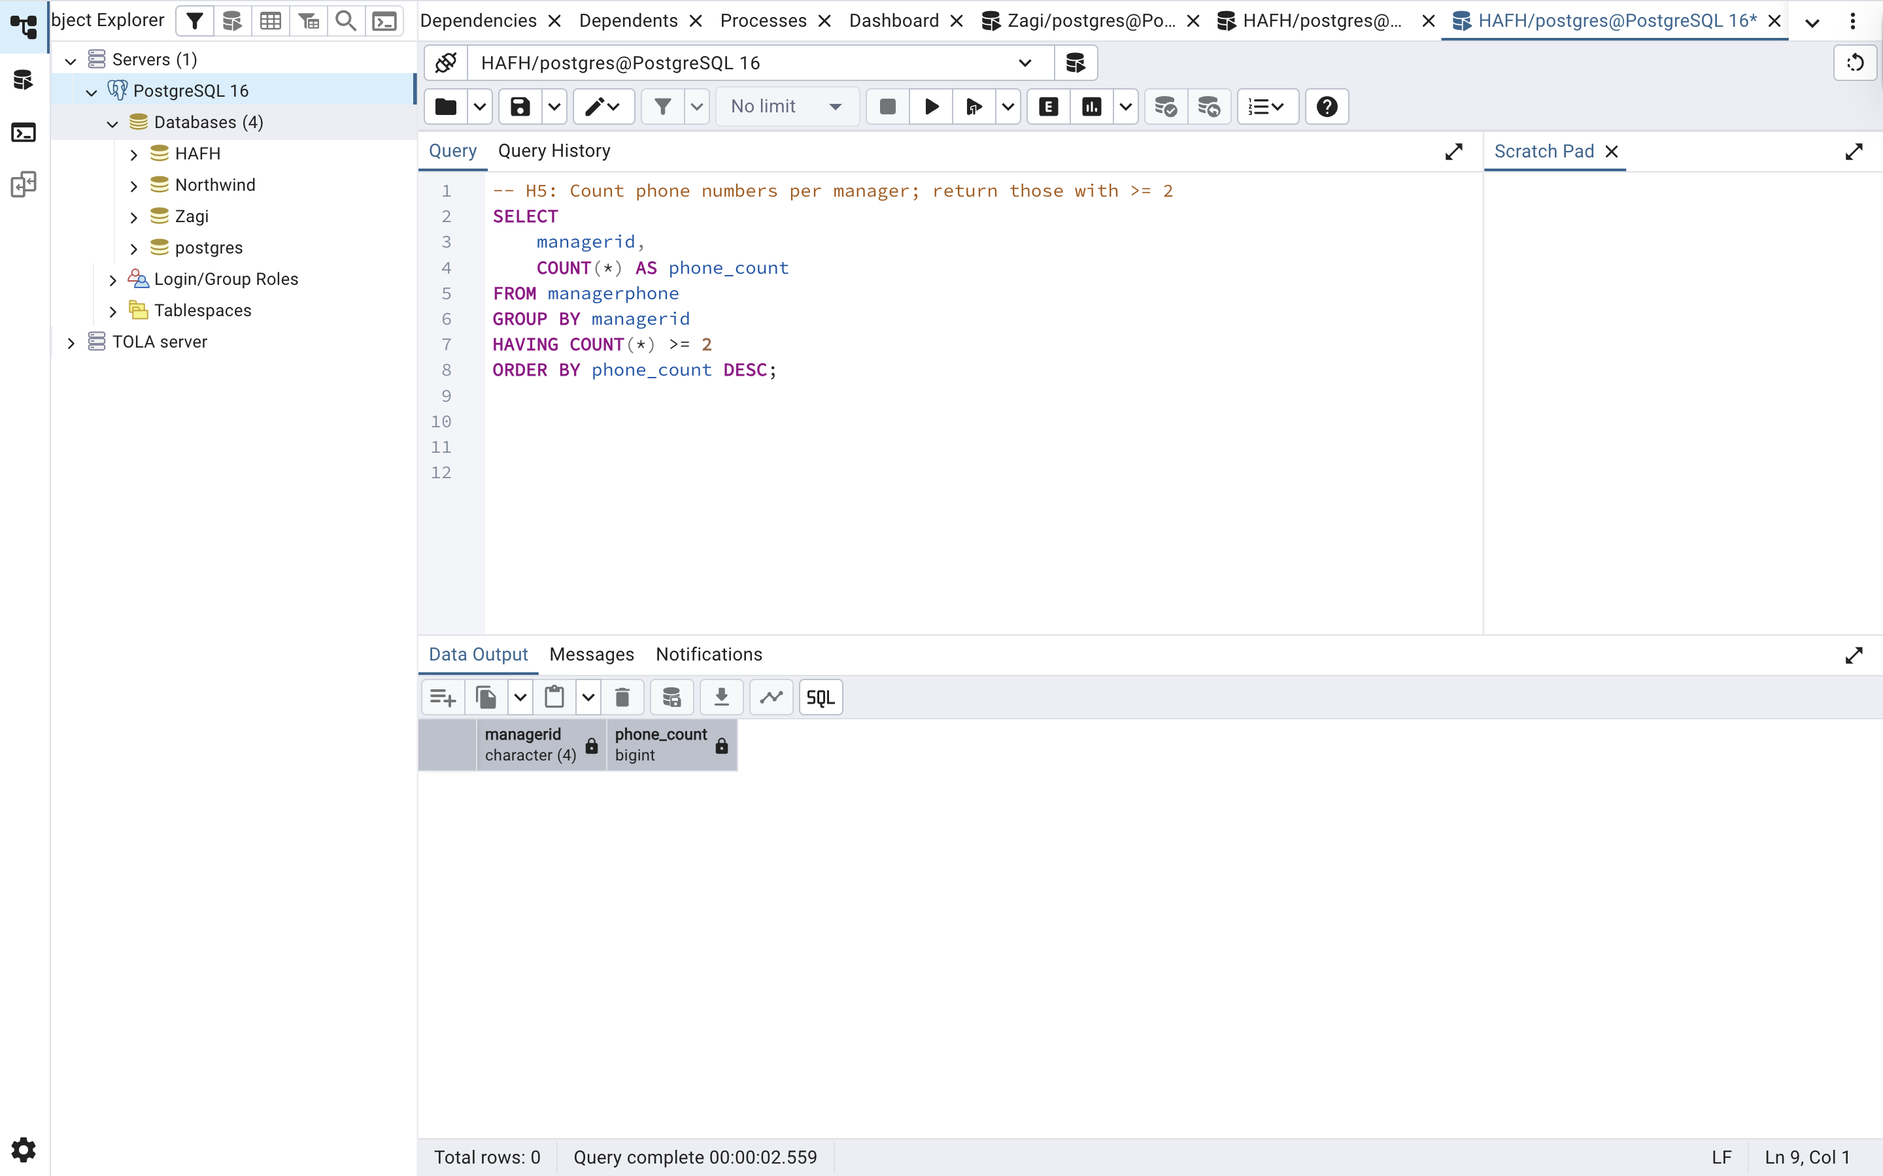

SECTION C — NORTHWIND (5 QUERIES)
N1 — Top 10 most expensive active products
QUESTION:
“Which of our currently active products are the most expensive? Show the top 10 with
their prices.”Analyst notes: Use products; filter active as discontinued = 0. Columns: productid, productname, unitprice. Sort by unitprice desc, then productname asc. Limit 10.
SQL CODE:
-- N1: Active products (discontinued = 0), top 10 by price
SELECT
productid,
productname,
unitprice
FROM products
WHERE discontinued = 0
ORDER BY unitprice DESC, productname ASC
LIMIT 10;

OUTPUT: 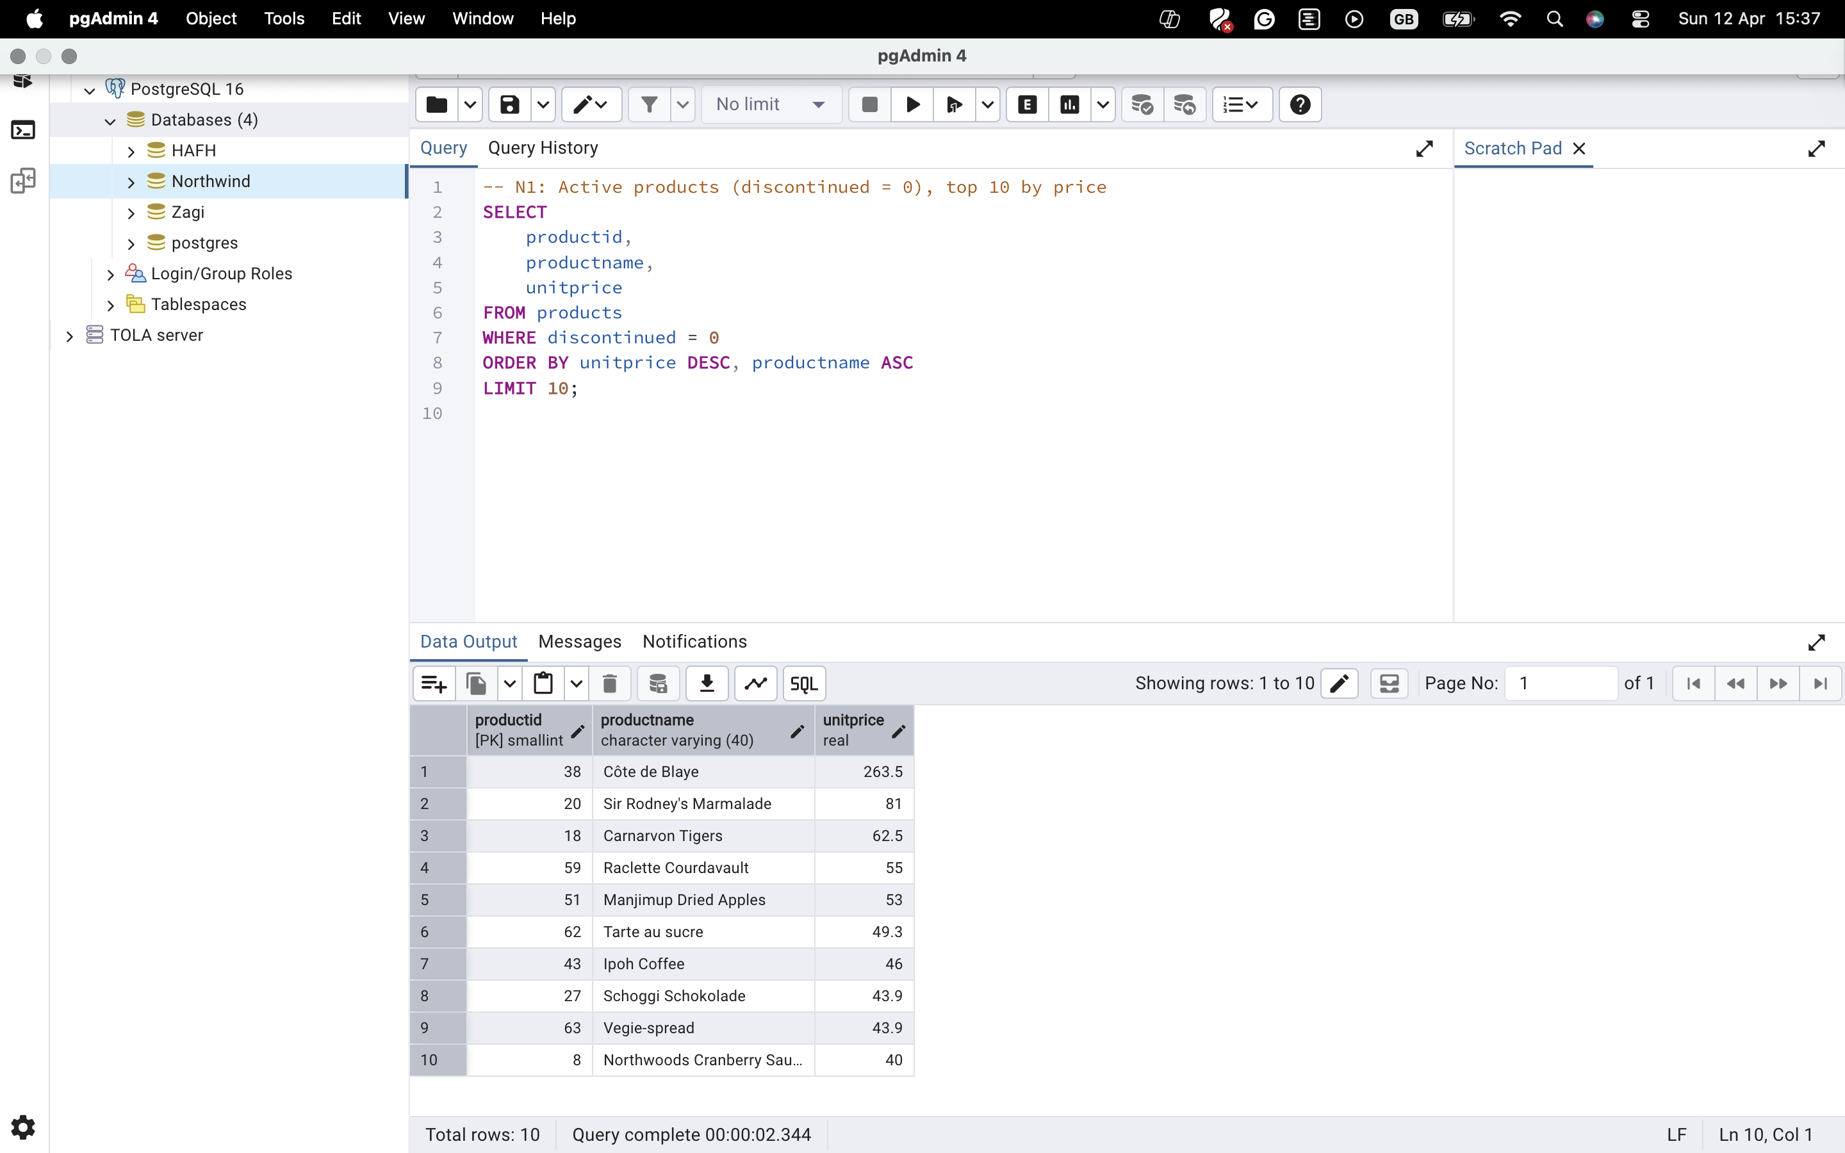

N2 — Top 5 customer countries
OUTPUT:
“Where are most of our customers located? Give me the top 5 countries by number of customers.” Analyst notes: Use customers. Columns: country, customer_count. Sort by customer_count desc, then country asc. Limit 5.

SQL CODE:
-- N2: Count customers per country; return top 5
SELECT
country,
COUNT(*) AS customer_count
FROM customers
GROUP BY country
ORDER BY customer_count DESC, country ASC
LIMIT 5;

OUTPUT:
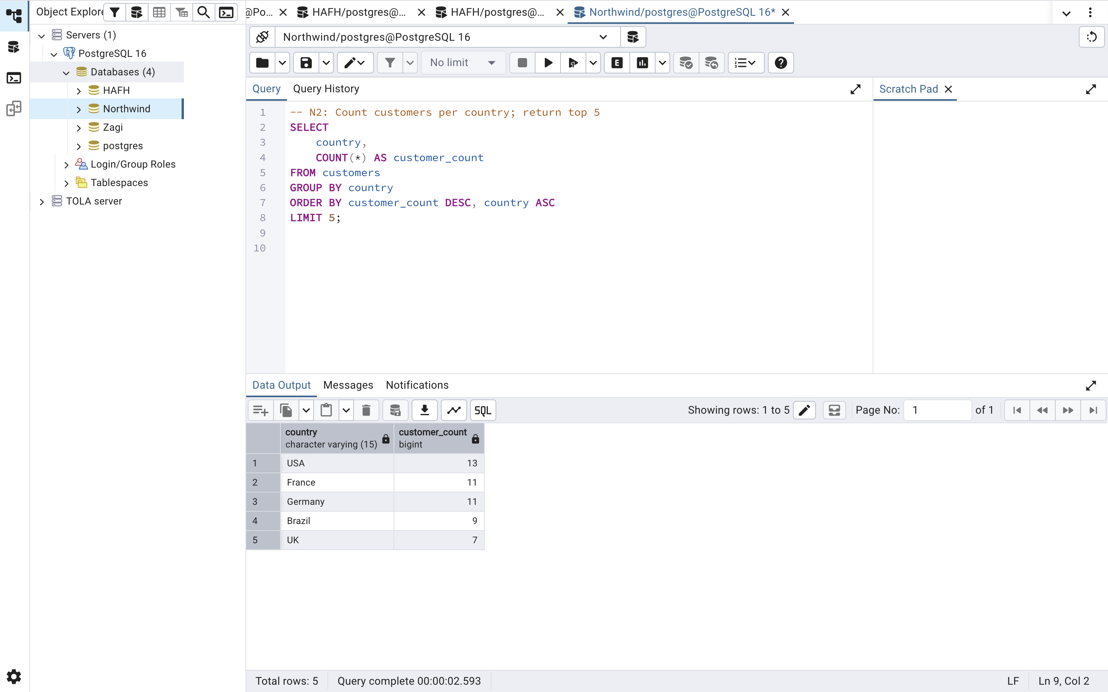

N3 — Number of orders received in 1996
Question:
“How many orders did we receive in the year 1996?”Analyst notes: Use orders. Return a single row column named orders_1996.

SQL CODE:
-- N3: Count orders from 1996
SELECT
COUNT(*) AS orders_1996
FROM orders
WHERE EXTRACT(YEAR FROM orderdate) = 1996;

OUTPUT: 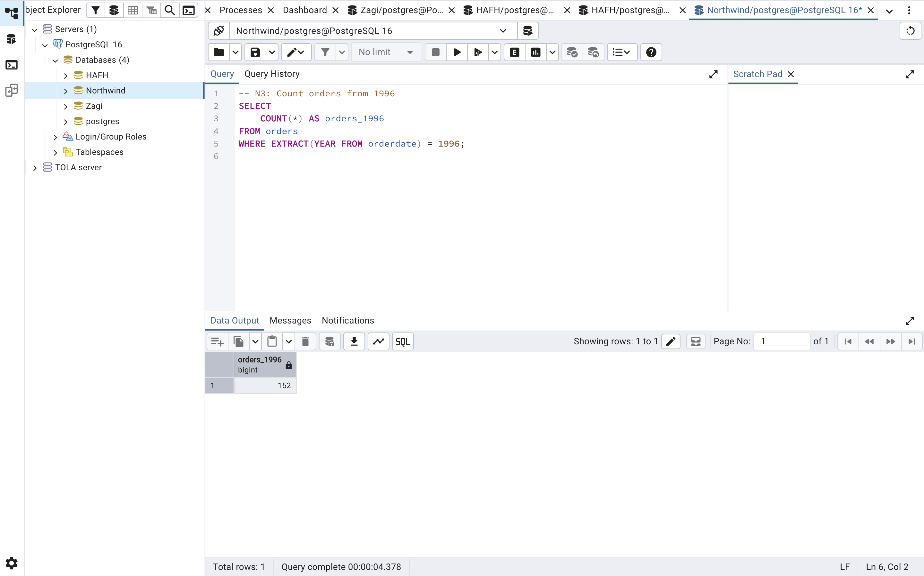

N4 — Top 5 products by line-item revenue
QUESTION:
“Which products drive the most line-item revenue? Give me the top 5 product IDs by revenue.”Analyst notes: Use order_details. Revenue per product = unitprice * quantity * (1 - discount) aggregated by productid. Columns: productid, total_revenue (round to 2 decimals). Sort desc. Limit 5.

SQL CODE:
-- N4: Top 5 products by line-item revenue (fixed ROUND issue)
SELECT
productid,
ROUND(
SUM((unitprice * quantity * (1 - discount))::numeric),
2
) AS total_revenue
FROM order_details
GROUP BY productid
ORDER BY total_revenue DESC
LIMIT 5;

OUTPUT: 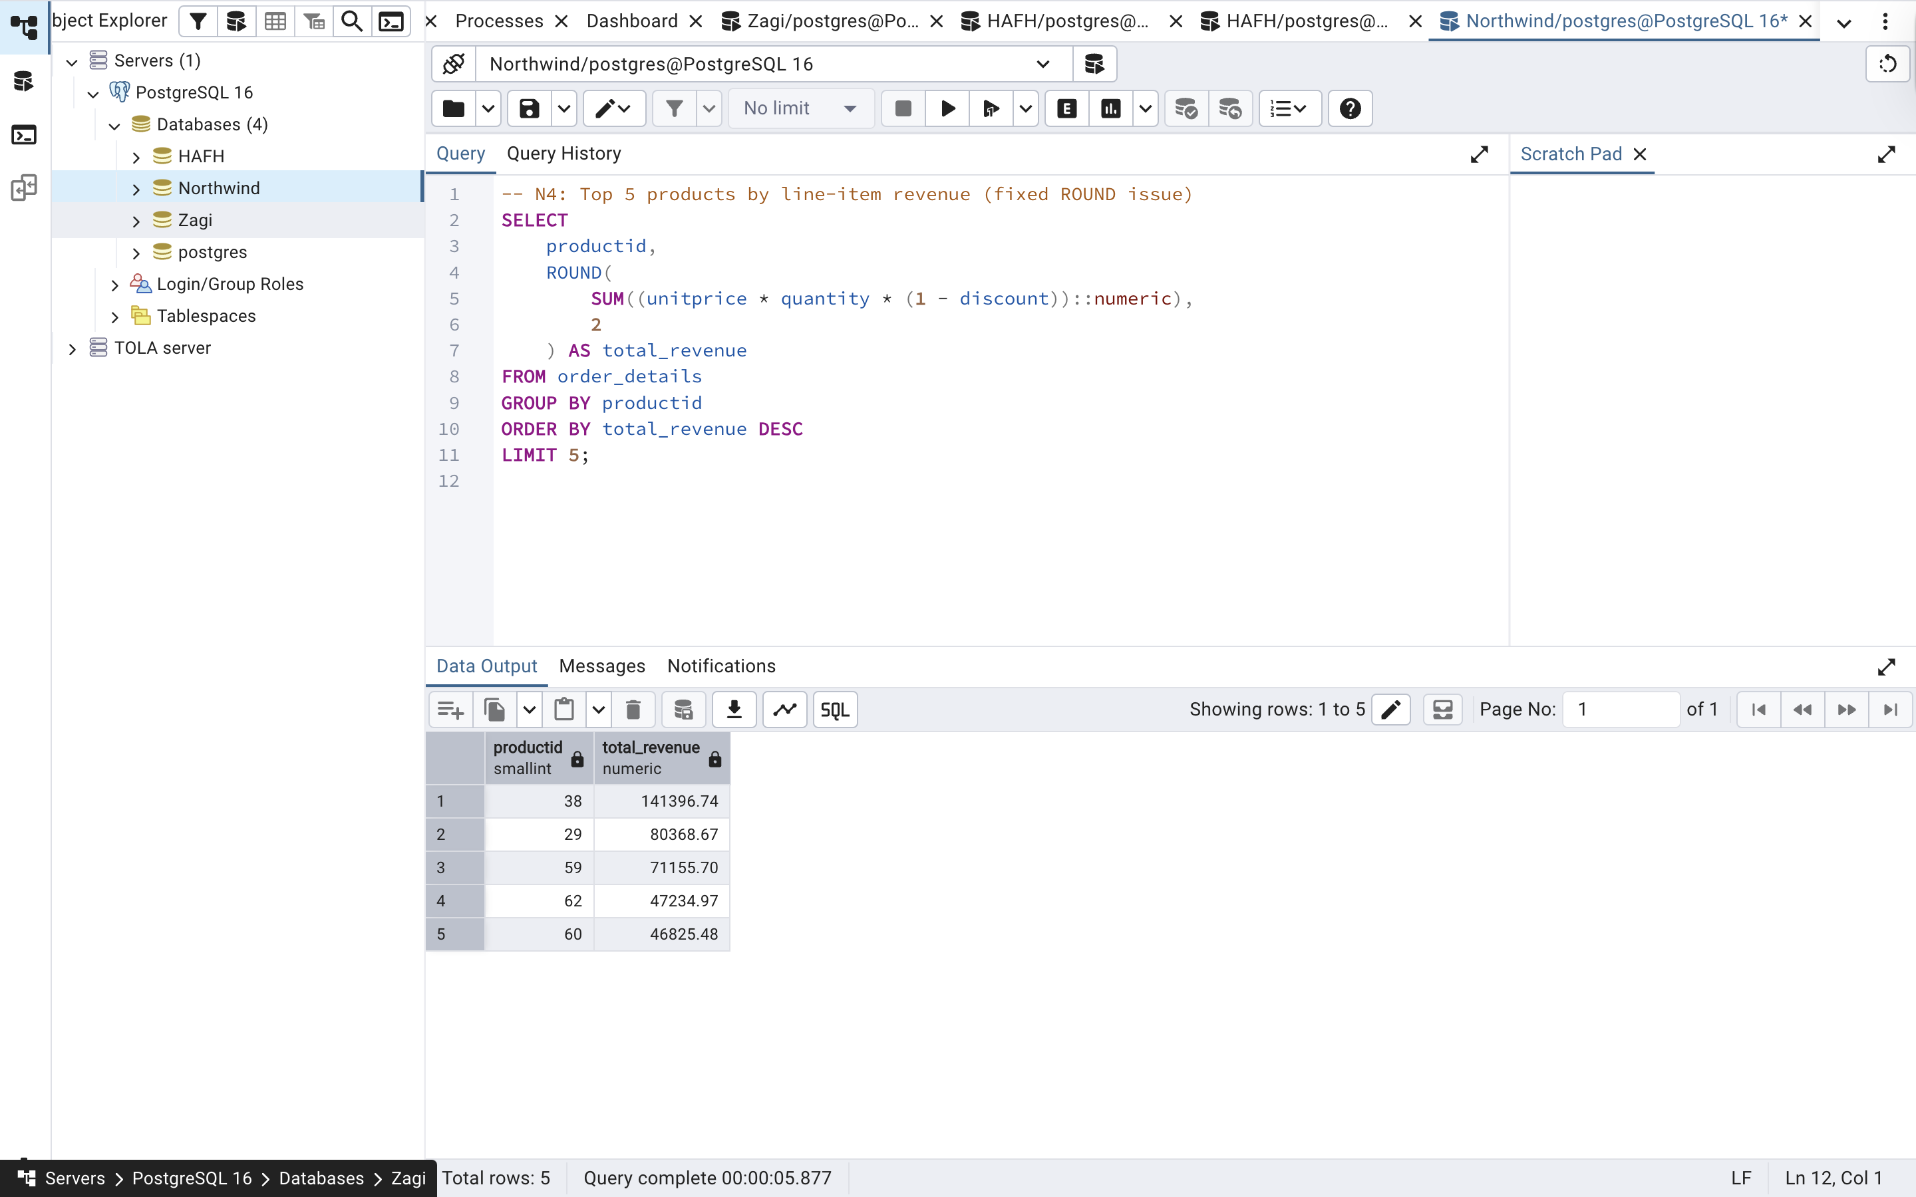

N5 — Employees hired in 1993
QUESTION:
“Who joined the company in 1993? List their names and hire dates.”Analyst notes: Use employees—columns: employeeid, firstname, lastname, hiredate. Sort by lastname, then firstname.

SQL CODE:
-- N5: Employees hired in 1993
SELECT
employeeid,
firstname,
lastname,
hiredate
FROM employees
WHERE EXTRACT(YEAR FROM hiredate) = 1993
ORDER BY lastname, firstname;

OUTPUT:
